Mechanistic Modeling and Image Analysis of Eukaryotic Centromeres
Improper chromosome segregation leads to chromosome instability, a hallmark of cancer. For this summer project, you will use image analysis, computational simulation, and big-data analysis to aid in our understanding of how the eukaryotic centromere is organized and how that organization helps facilitate proper chromosome segregation. During this summer project, students can familiarize themselves with:
- Fluorescent microscopy in live cells
- Image analysis techniques
- MATLAB coding
- Polymer simulations
- Big-data analysis
The overall goals of this summer project is to compare output from a polymer simulation to actual live cell images. Students with previous MATLAB or coding experience are preferred.
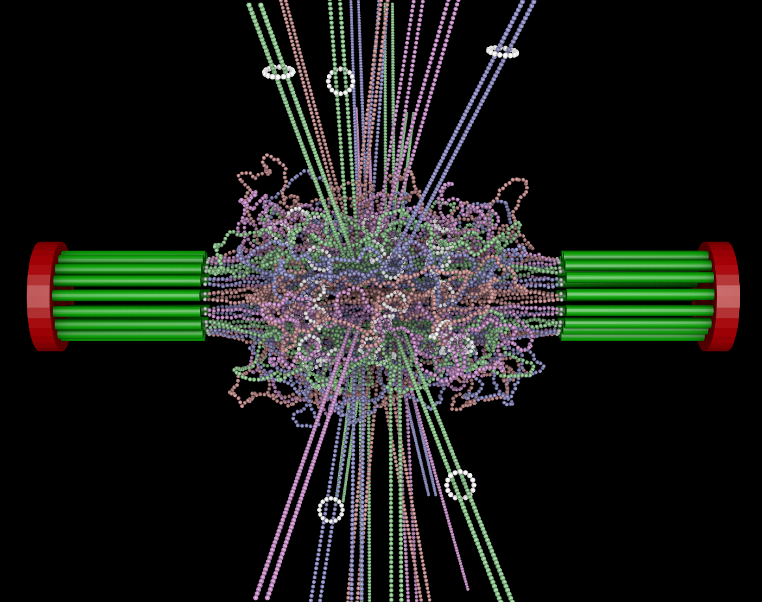
Budding Yeast Centromere

